Ex. No. 6 | RECORDING OF NOTEPAD AUTOMATION
Date of Exercise | 30/01/2026

AIM
To automate the notepad with recording using UiPath.
DESCRIPTION
Robotic Process Automation (RPA) automates repetitive tasks by mimicking human actions. In this experiment, UiPath Studio is used to automate the Notepad application using the recording feature, which captures actions like typing text and saving files. The recorded workflow is executed to automatically create, edit, and save a Notepad file, demonstrating how UiPath simplifies basic desktop automation.
PROCEDURE:
Step 1: Open UiPath studio and click process to start a new project.
Step 2: Create a new blank process by giving a name and give create.
Step 3: Click Open main workflow.
Step 4: You will get the main workflow.
Step 5: Open notepad application
Step 6: From the design ribbon click on the App/Web recording.
Step 7: Select the notepad application by indicating the window.
Step 8: Type the text to enter in the notepad as a dialog box appears.
Step 9: To select file go to click and chose file.
Step 10: Next to save the file, Chose click and give F2. Then chose save as.
Step 11: Enter the file name in the dialog box.
Step 12: Use click to save the file.
Step 13: UiPath workspace will open. Run the program.
OUTPUT:
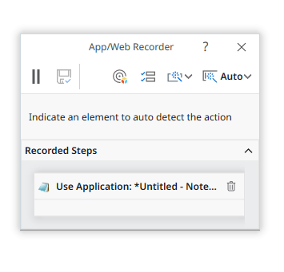
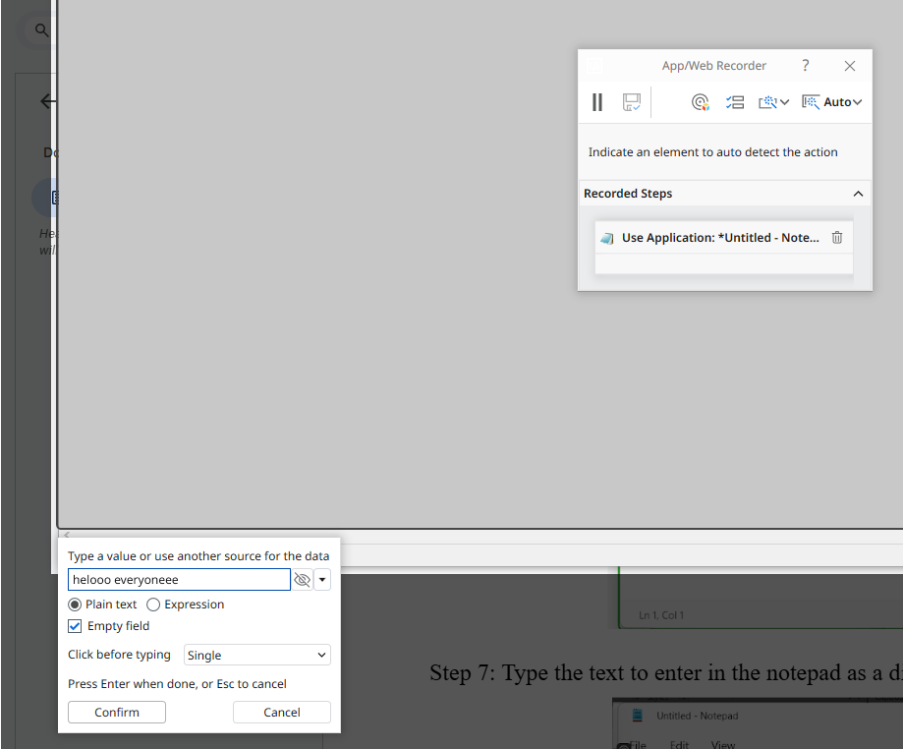
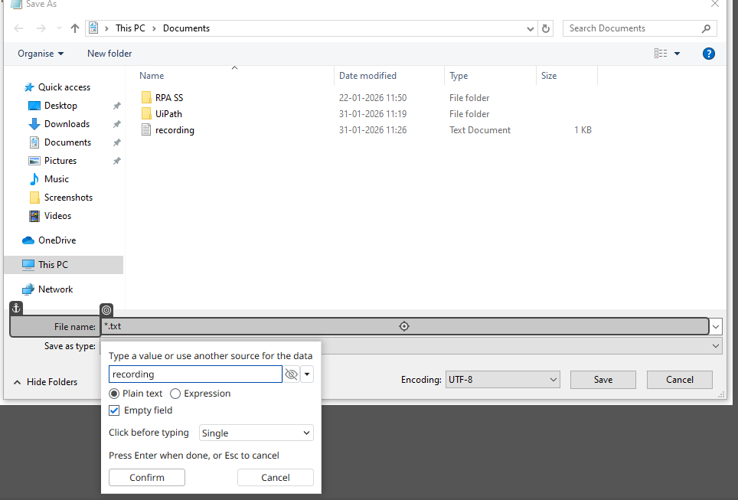

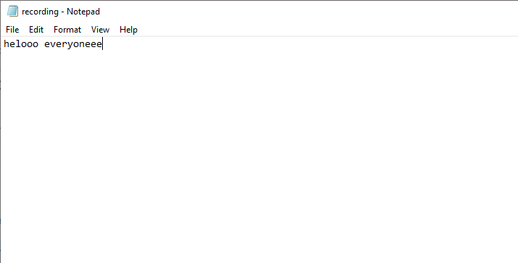

Result:
Thus, the recording of notepad automation is completed successfully.

